Cody Hanks
ECE 479 Robotics II
2013 – Home work 1
Using Octave and image package I was able to practice several of the techniques you previously mentioned in the lectures. After trying several of the operations mentioned in class I decided to work mainly with erosion. After taking pictures of several hallways I used them to run several processes and develop some additional information. Below is the first image used in this project, we can easily see the hallway and several doors.
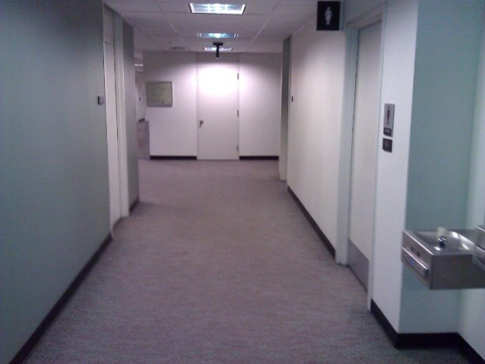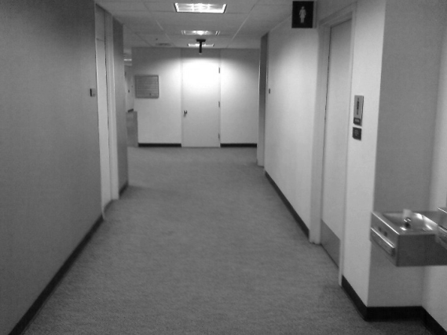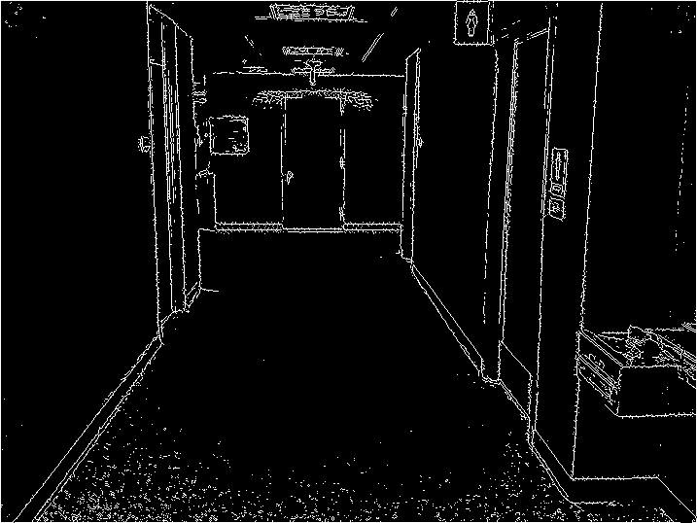

With the second image I tired to further use different structuring elements starting with a 5x5 matrix of ones and moving to a 10x10, 20x20, 30x30 and 40x40. After completing several passes on the image and using edge detection I was able to get several elements from the photo such as the light fixtures on the celling, I found it really difficult to get rid of the noise on the photo, and found that running erosion both before and after using edge detection provided the best resulst.

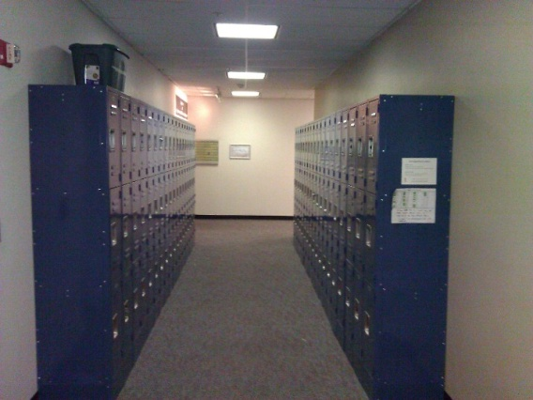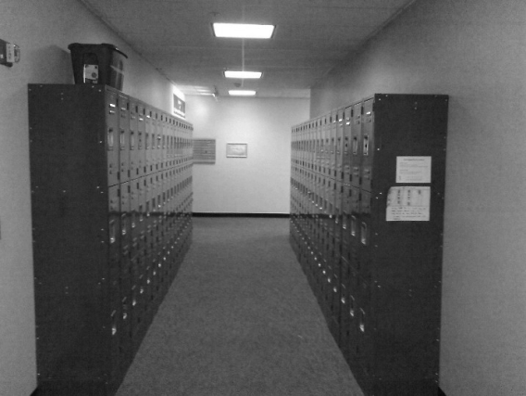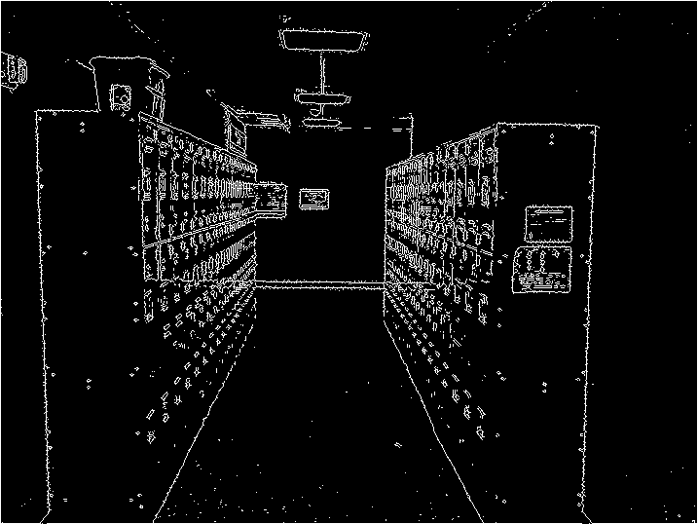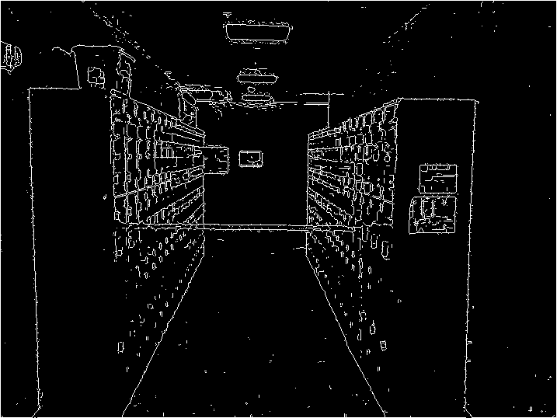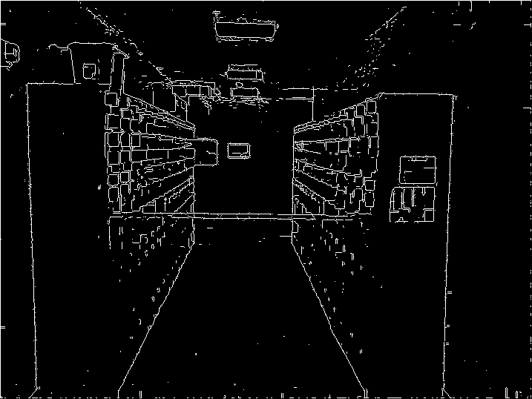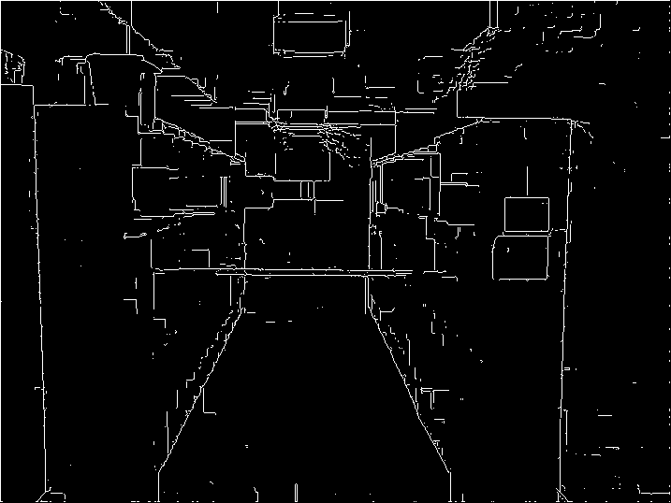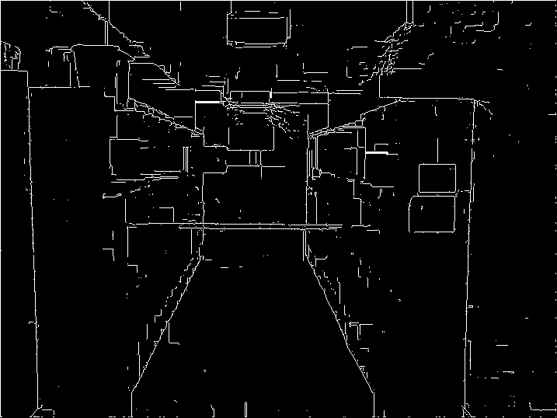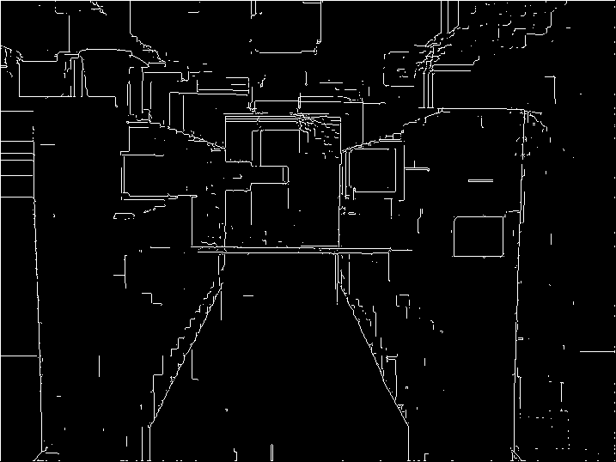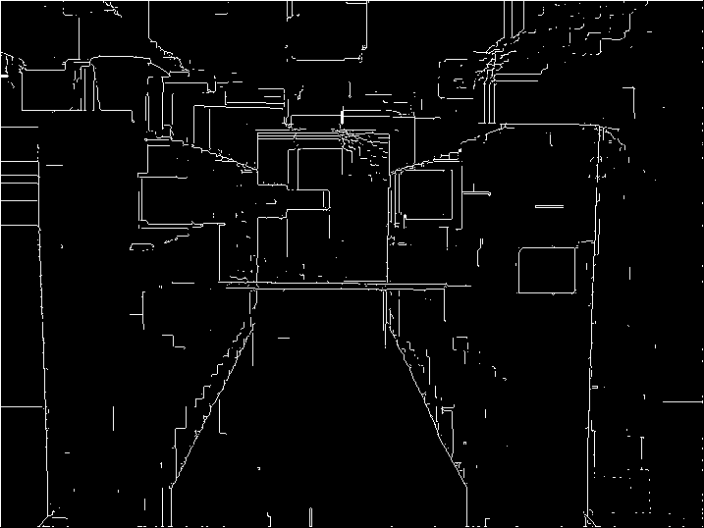

For the last photo I use a mostly empty hallway and again found that running erosion before and after the edge detection provided the least noise.
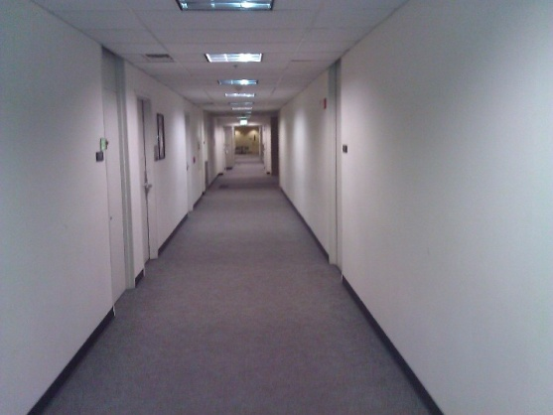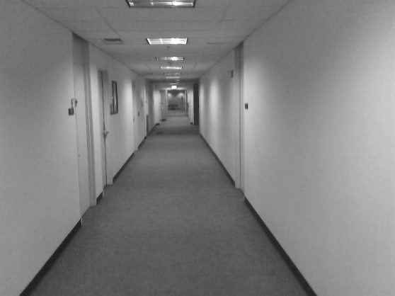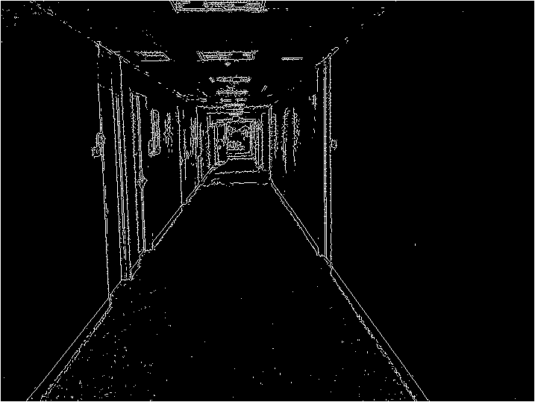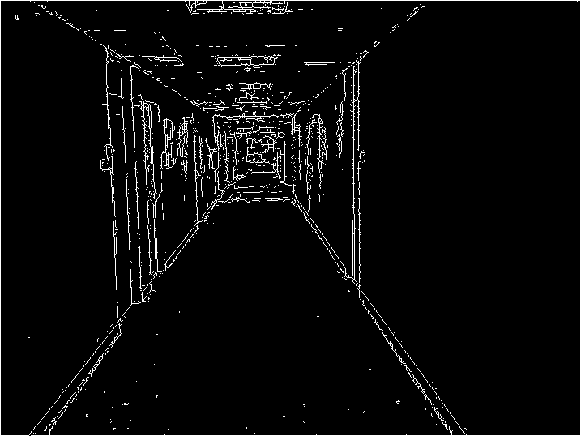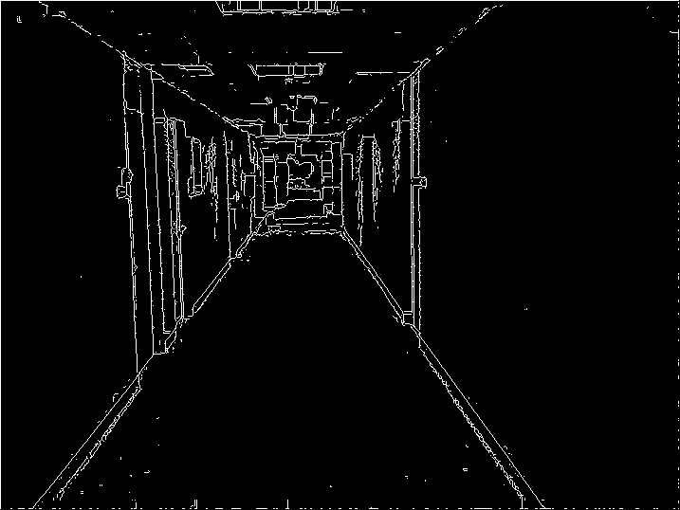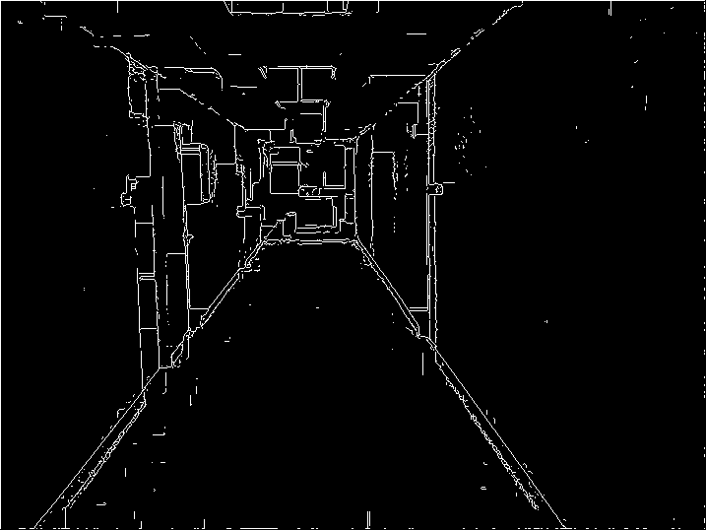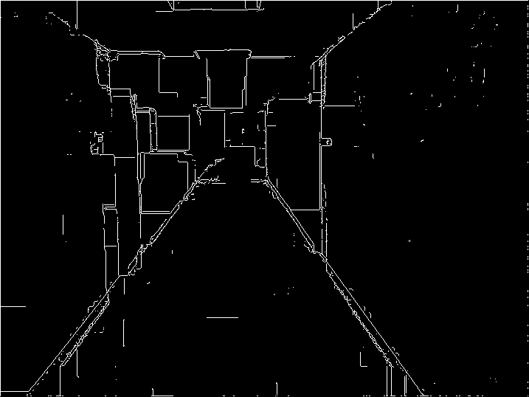

Starting Octave...
GNU Octave, version 3.2.4
Copyright (C) 2009 John W. Eaton and others.
This is free software; see the source code for copying conditions.
There is ABSOLUTELY NO WARRANTY; not even for MERCHANTABILITY or
FITNESS FOR A PARTICULAR PURPOSE. For details, type `warranty'.

Octave was configured for "i686-pc-linux-gnu".

Additional information about Octave is available at http://www.octave.org.

Please contribute if you find this software useful.
For more information, visit http://www.octave.org/help-wanted.html

Report bugs to <bug@octave.org> (but first, please read
http://www.octave.org/bugs.html to learn how to write a helpful report).

For information about changes from previous versions, type `news'.

>>> imwrite(rgb2gray(imread("~/Documents/imgs/hallway.jpg")),"~/Documents/imgs/
hallway.bmp");
>>> imwrite(rgb2gray(imread("~/Documents/imgs/hallwaylock.jpg")),"~/Documents/i
mgs/hallwaylock.bmp");
>>> imwrite(rgb2gray(imread("~/Documents/imgs/hallwaywdring.jpg")),"~/Documents
/imgs/hallwaywdring.bmp");
>>> imwrite(edge(imread("~/Documents/imgs/hallwaylock.bmp")),"~/Documents/imgs/
hallwaylockedge.bmp");
>>> imwrite(edge(imread("~/Documents/imgs/hallway.bmp")),"~/Documents/imgs/hall
way.bmp");
>>> imwrite(edge(imread("~/Documents/imgs/hallwaywdring.bmp")),"~/Documents/img
s/hallwaywdring.bmp");
>>> imwrite(rgb2gray(imread("~/Documents/imgs/hallway.jpg")),"~/Documents/imgs/
hallway.bmp");
>>> imwrite(rgb2gray(imread("~/Documents/imgs/hallwaywdring.jpg")),"~/Documents
/imgs/hallwaywdring.bmp");
>>> imwrite(edge(imopen(imread("~/Documents/imgs/hallway.bmp"),ones(5,5))),"~/D
ocuments/imgs/hallwayopenedge.bmp");
>>> imwrite(edge(imopen(imread("~/Documents/imgs/hallway.bmp"),ones(10,10))),"~
/Documents/imgs/hallwayopenedge.bmp");
>>> imwrite(edge(imopen(imread("~/Documents/imgs/hallway.bmp"),ones(10,10))),"~
/Documents/imgs/hallwayopen10edge.bmp");
>>> imwrite(edge(imopen(imread("~/Documents/imgs/hallway.bmp"),ones(5,5))),"~/D
ocuments/imgs/hallwayopen5edge.bmp");
>>> imwrite(edge(imopen(imread("~/Documents/imgs/hallwaylock.bmp"),ones(5,5))),
"~/Documents/imgs/hallwaylockopen5edge.bmp");
>>> imwrite(edge(imopen(imread("~/Documents/imgs/hallwaylock.bmp"),ones(10,10))
),"~/Documents/imgs/hallwaylockopen10edge.bmp");
>>> imwrite(edge(imopen(imread("~/Documents/imgs/hallwaylock.bmp"),ones(30,30))
),"~/Documents/imgs/hallwaylockopen30edge.bmp");
imwrite(edge(imopen(imread("~/Documents/imgs/hallwaylock.bmp"),ones(30,30))),"
~/Documents/imgs/hallwaylockopen30edge.bmp");
>>> imwrite(edge(imopen(imread("~/Documents/imgs/hallwaylock.bmp"),ones(30,30))
),"~/Documents/imgs/hallwaylockopen20edge.bmp");
>>> imwrite(edge(imopen(imread("~/Documents/imgs/hallwaylock.bmp"),ones(40,40))
),"~/Documents/imgs/hallwaylockopen40edge.bmp");
>>> imwrite(edge(imopen(imread("~/Documents/imgs/hallway.bmp"),ones(40,40))),"~
/Documents/imgs/hallwayopen40edge.bmp");
>>> imwrite(edge(imopen(imread("~/Documents/imgs/hallway.bmp"),ones(20,20))),"~
/Documents/imgs/hallwayopen20edge.bmp");
>>> imshow(imerode(imread("~/Documents/imgs/hallwaylockopen20edge.bmp"),ones(7,
7)));
>>> [i idx] =bwfill(imread("~/Documents/imgs/hallwaylockopen20edge.bmp"),"holes
",n);
error: `n' undefined near line 137 column 80
error: evaluating argument list element number 3
>>>error: evaluating argument list element number 1
>>> [i idx] =bwfill(imread("~/Documents/imgs/hallwaylockopen20edge.bmp"),"holes
");
>>> [i idx] =bwfill(imread("~/Documents/imgs/hallwaylockopen20edge.bmp"),"holes
");imwrite(i,"~/Documents/imgs/hallwaylockopen20edgefill.bmp")
>>> [i idx] =bwfill(imread("~/Documents/imgs/hallwaylockopen40edge.bmp"),"holes
");imwrite(i,"~/Documents/imgs/hallwaylockopen40edgefill.bmp")
>>>

